EER Diagram:

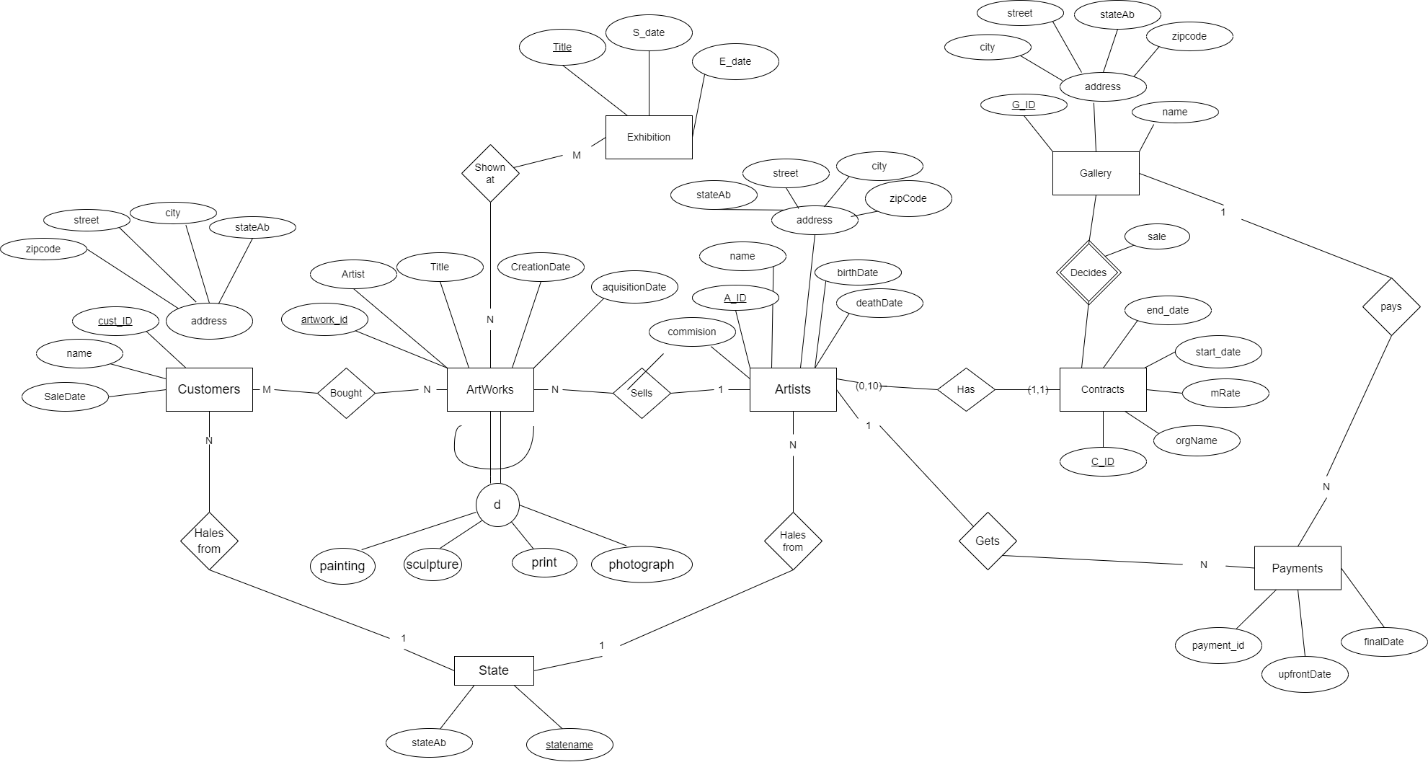

* Entity Exhibition is aded in EER diagram to showcase the artworks.

Relational Diagram:

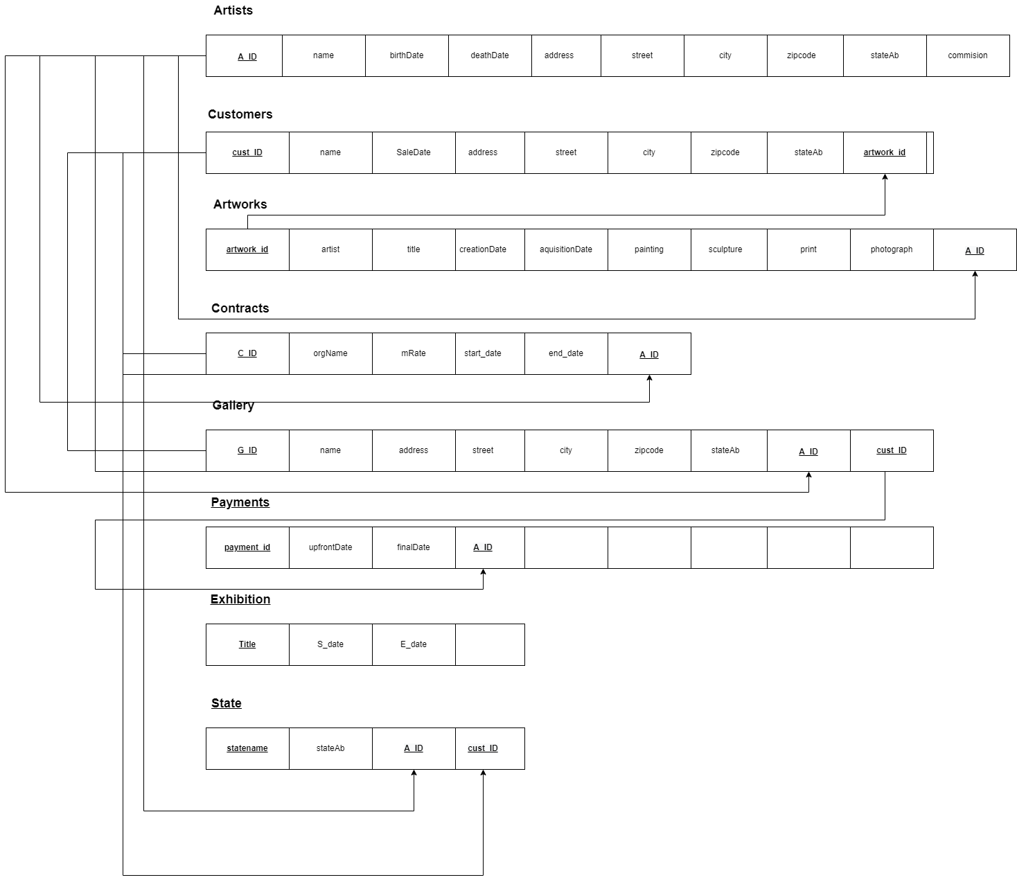

What we did:

* We discussed the every requirement in the problem statement and implemented it through app.diagrams.net

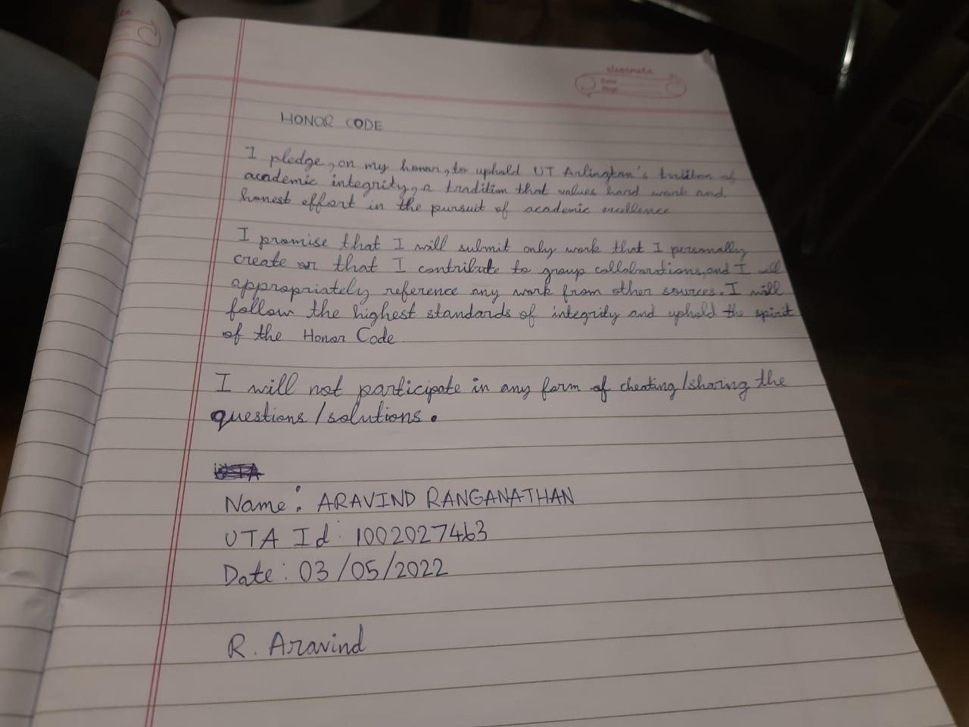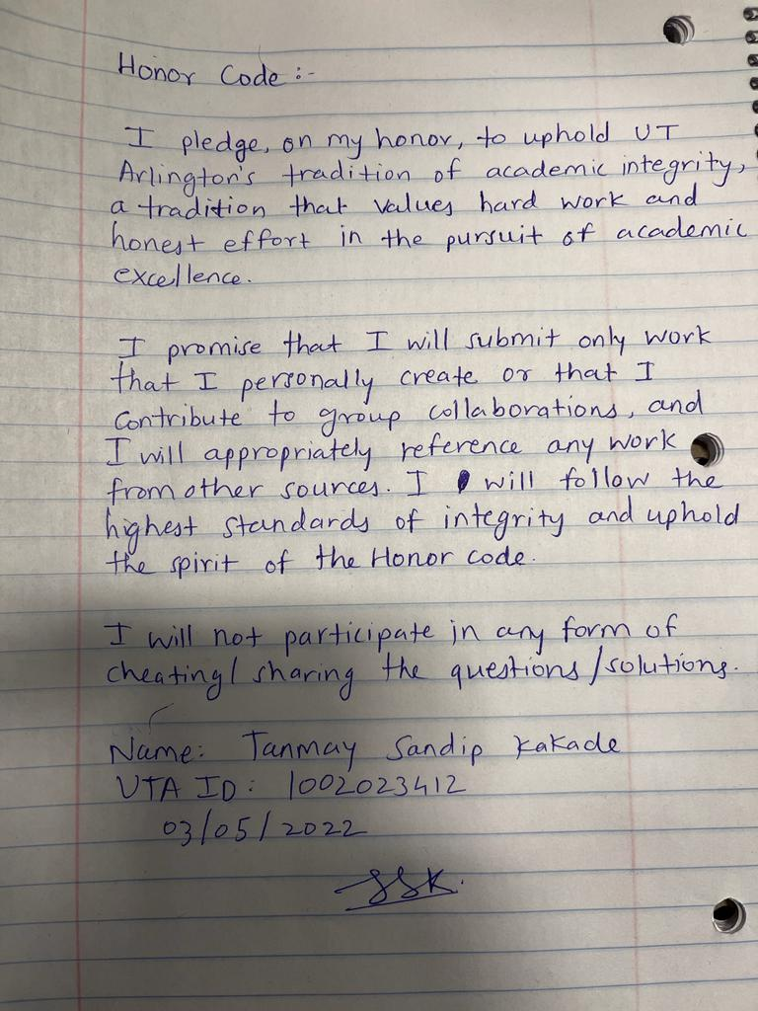

Name : Tanmay Sandeep Kakade Name : Aravind Ranganathan

UTA ID : 1002023412 UTA ID : 1002027463